**Unschool**

**C & C++ Assignment**

**Name:-** Vaidehi Dayaram Dahare

**E-mail:-** [Vaidehidahare06@gmail.com](mailto:Vaidehidahare06@gmail.com)

Assignment 2:-

Write a calculator program, keeping following things in mind:

:-> Take two numbers as input from user

:-> Apply +,-,*, / and % operations on them

:->Upload this code to Github repository.

Source Code:-

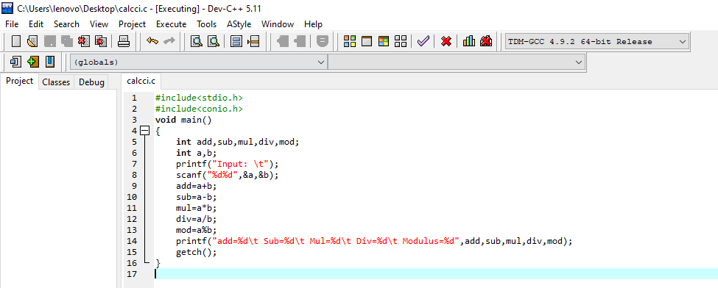

Output:-

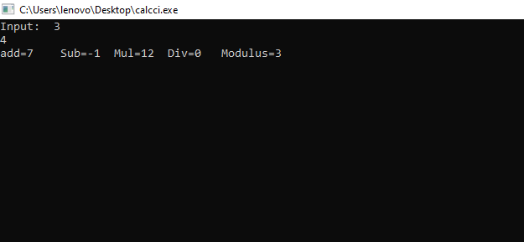

Or

